**Azure DevOps Pipeline**

Assignment - 1

Azure DevOps Pipeline is a set of Tasks that are executed in a sequence by the Agent. Sometimes, it may be required to execute a particular task based on some logical condition. Below are some scenarios.

Built-In Conditions

1. Execute one of the Pipeline tasks (say AuditLog) only when the rest of ALL pipeline Tasks fail. The AuditLog task could log some details about the failure of all tasks.
2. Execute one of the Pipeline Tasks only when its dependent task(s) fails.

You can also have your own custom conditions to control the execution of the Tasks. Below are a few examples.

Custom Conditions

1. Execute one of the Pipeline Tasks ONLY if the value of a variable is true.
2. Execute one of the Pipeline Tasks ONLY if the current branch is developed.
3. Execute the Pipeline ONLY if the pipeline is executed automatically (Continuous Integration)

Assignment - 2

When you plan to implement Infra automation, you may want to implement something shown below.

1. Create a Storage Account and create a SAS token in one Task.
2. In subsequent Tasks, you may need the SAS token to access Storage Account in another Task.

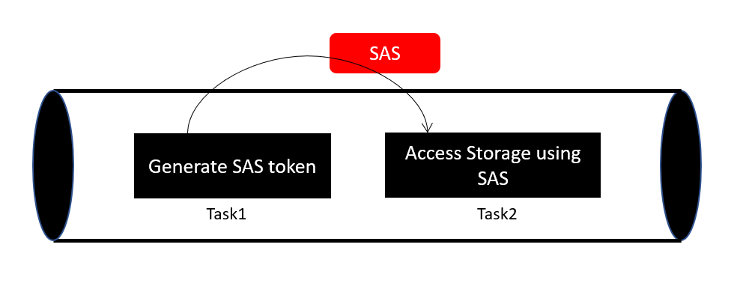

The above Tasks may be located in the same Job, different Jobs within a Stage, or across Stages. We are going to learn how to achieve the functionality of passing values in all these scenarios.

Assignment - 2

Create a store of all notification emails in a Common Email box (ex: [logpipelinenoticiations@example.com](mailto:logpipelinenoticiations@example.com)) to audit all the Failures or Partially Succeeded pipeline executions.

Maybe, you may want to store these notifications ONLY for the most critical pipelines instead of all the pipelines for a given ADO Team Project.

Assignment - 3

create and configure a Self-Hosted Agent in Azure DevOps (ADO).

Azure DevOps supports the following two types of Agents

* Microsoft Hosted Agent – These agents are managed by Microsoft
* Self-Hosted Agents – These are created and managed by the Customer.

Advertisements

REPORT THIS AD

Most of the time, using Microsoft-hosted Agents should be good. However, below are the scenarios in which you should look at configuring Self-Hosted Agents

1. If 10GB of free space in the Virtual Machine (Agent) is not sufficient for your build needs.
2. When you want a Virtual Machine, whose capacity is greater than that of Standard DS2V2
3. When you would like to use Software that is not available in the Microsoft-hosted Build Agents

we will focus on how to configure the Self Hosted Agents.

Prerequisites:

1. A Valid Azure DevOps account. You can create one at dev.azure.com
2. Create an ADO Organization
   1. Create a Project.
3. A Server that you would like to make as an Agent (I have created a Windows Virtual Machine in Azure)

Assignment - 4

The Azure DevOps allows us to restrict direct commits to the main branch using a feature called Branch Policies. Azure DevOps supports multiple types of policies. we will learn about the very simple policy which restricts direct commits to the main branch.

Once the policy has been applied, the only way to merge the feature branch to the main branch is via Pull Requests. Let’s now understand how to configure the Branch Policies on a branch.